Student’s Name: Kibet Brian
Admission Number: 190814
Lecturer’s Name: Mr. Talo Harrison
Course Unit: MST 8303 Penetration Testing, PT
Course Code: MST 8303
Lab – Session Hijacking Using ZAP
Date: August 14th, 2025

Lab – Session Hijacking Using ZAP
Firefox launched in Windows 10.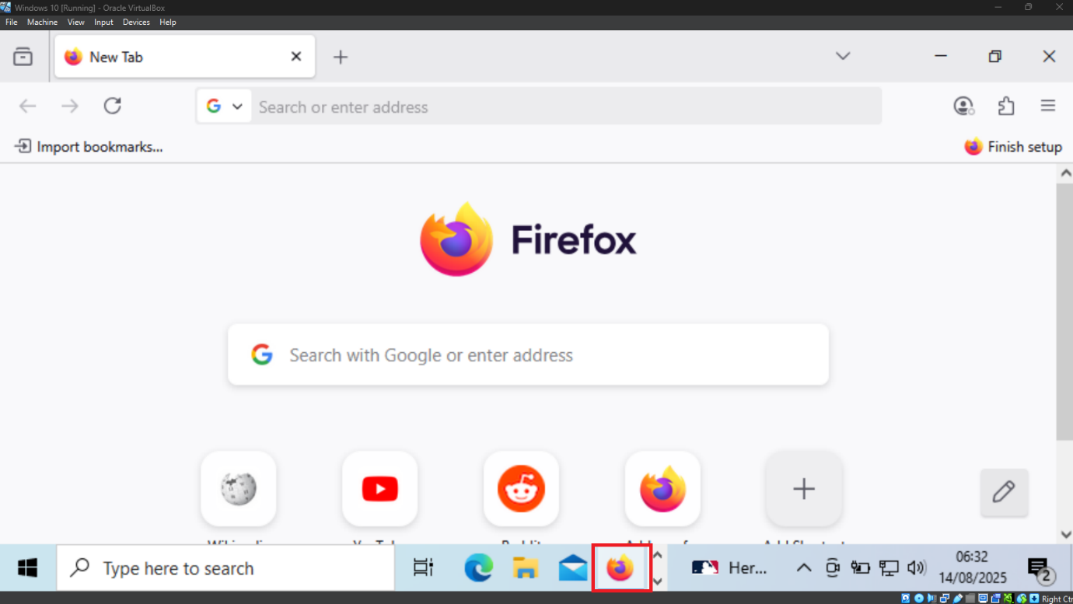

Windows Server (Attacker’s IP). 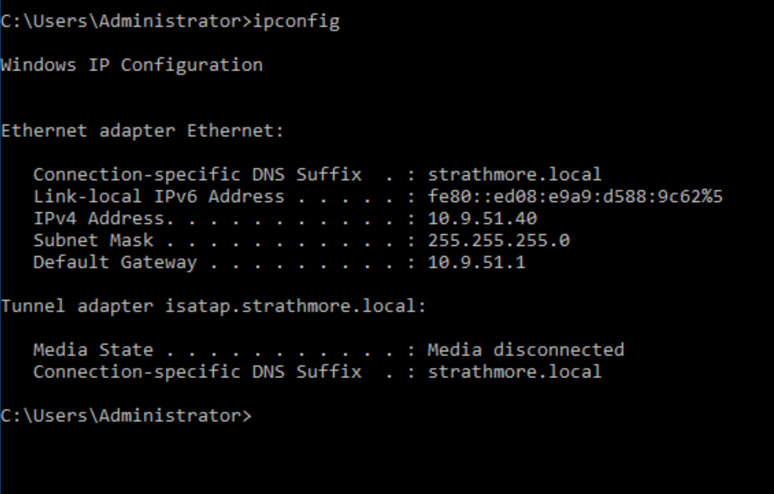
Proxy Settings. 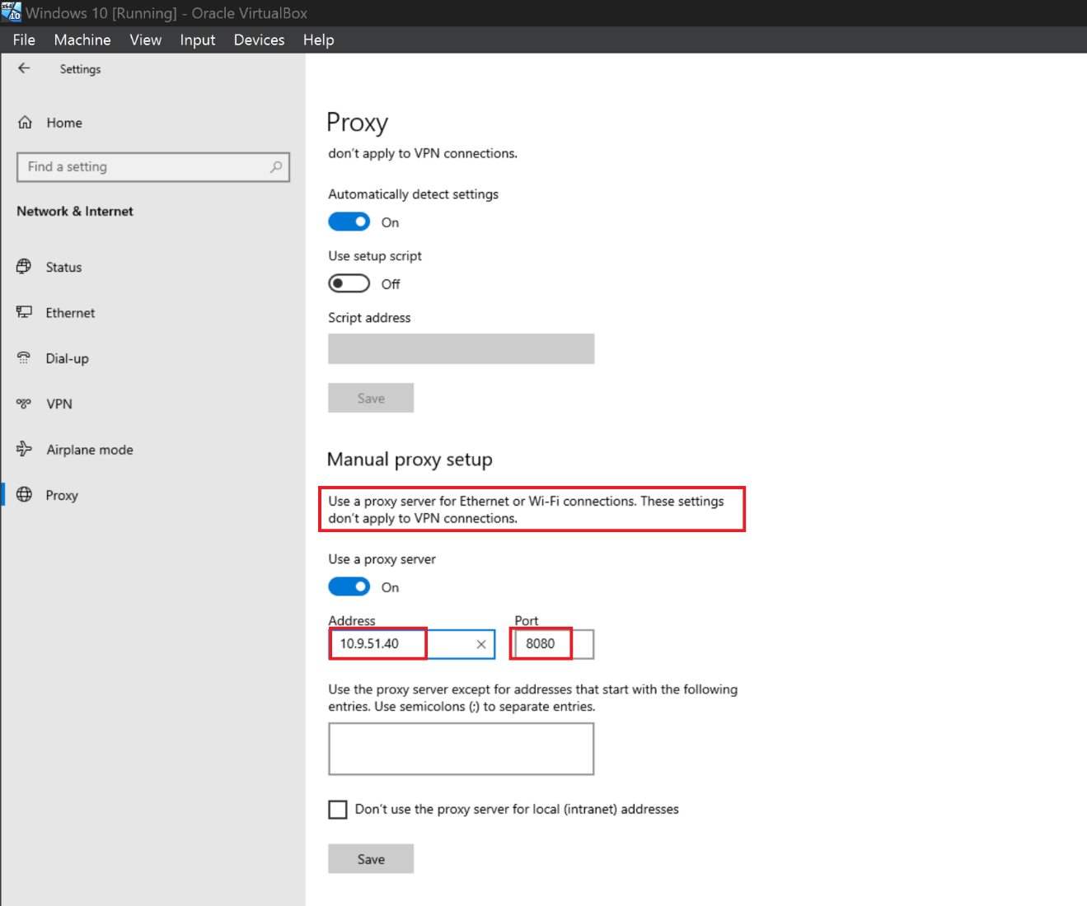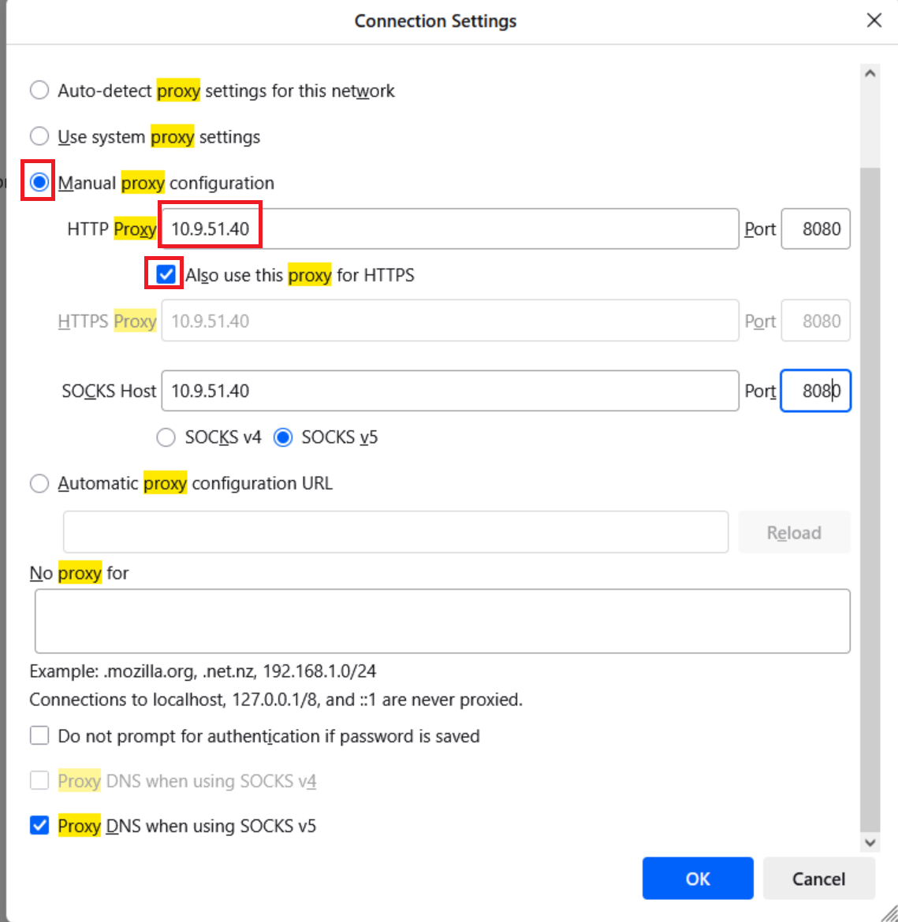
Checking the Proxy Server checkbox and typing the attacker’s IP address and port 8080.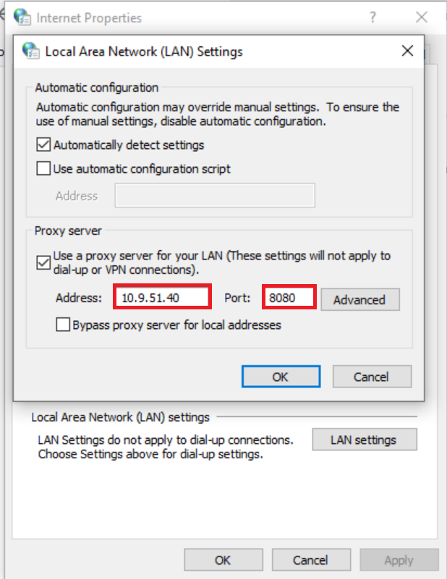
Setting up ZAP (Zed Attack Proxy).
Java Runtime is already installed.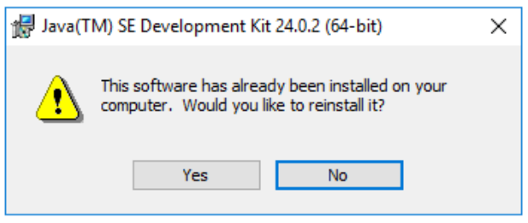

Setting up ZAP.
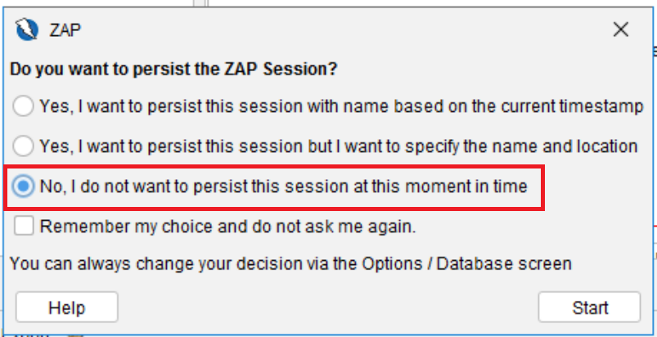
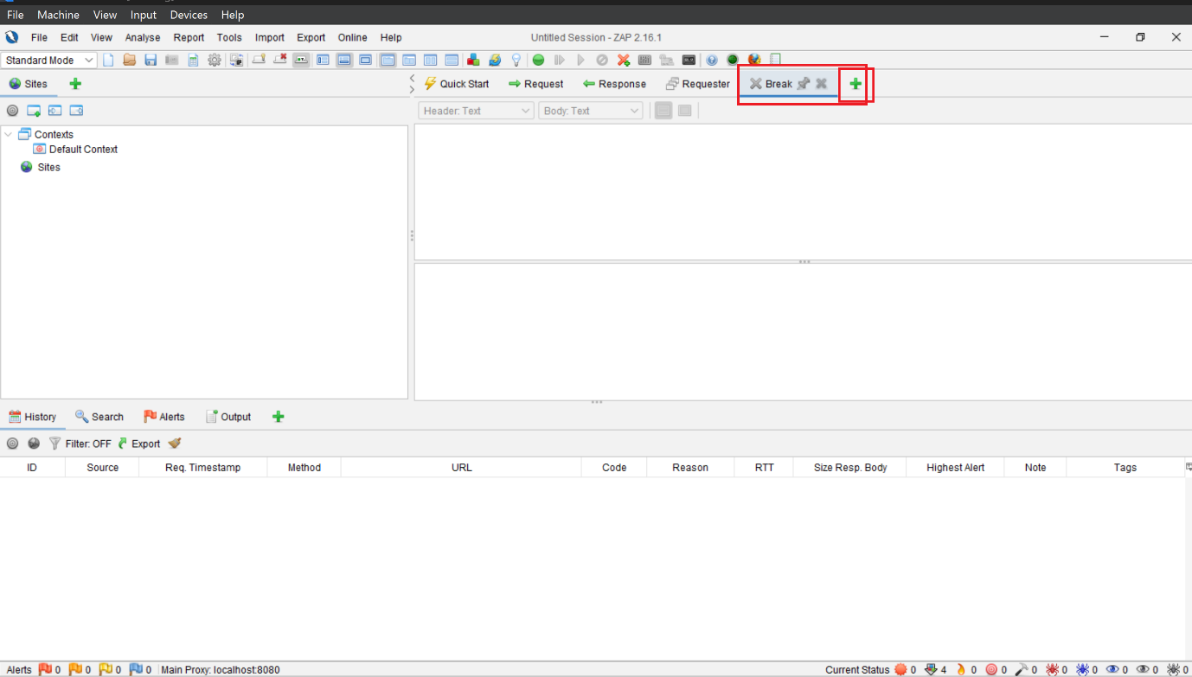

Options tab.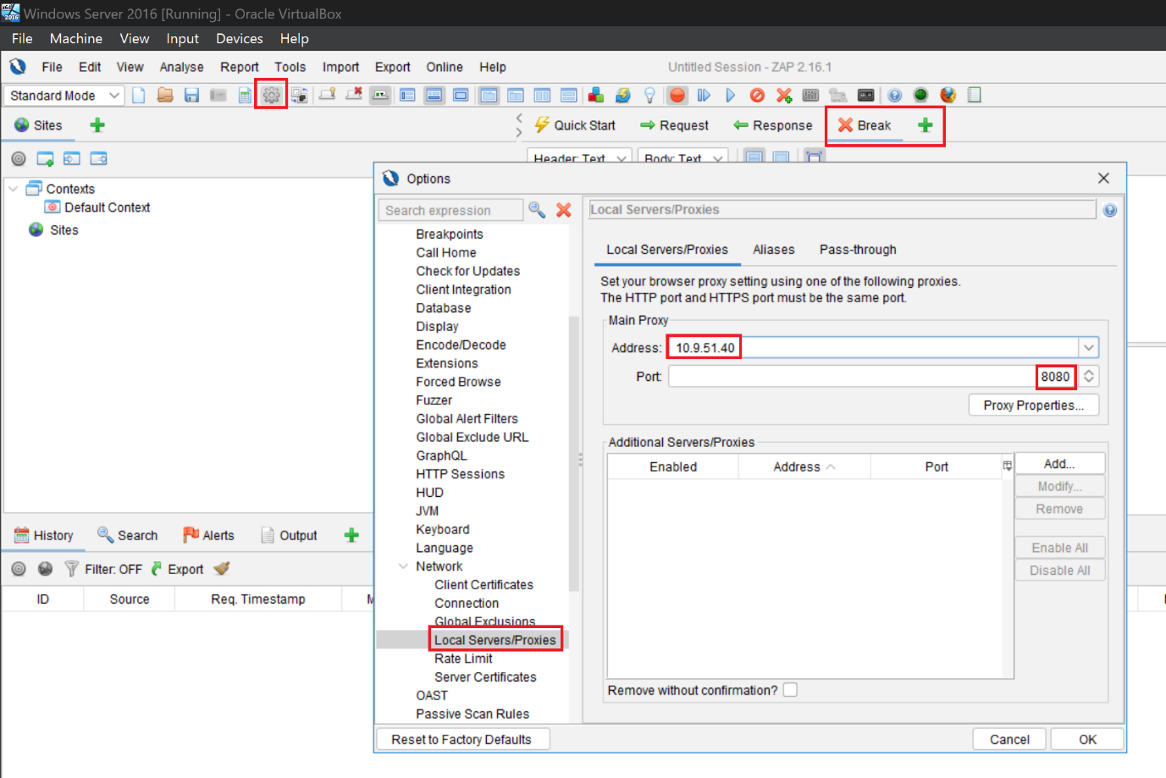

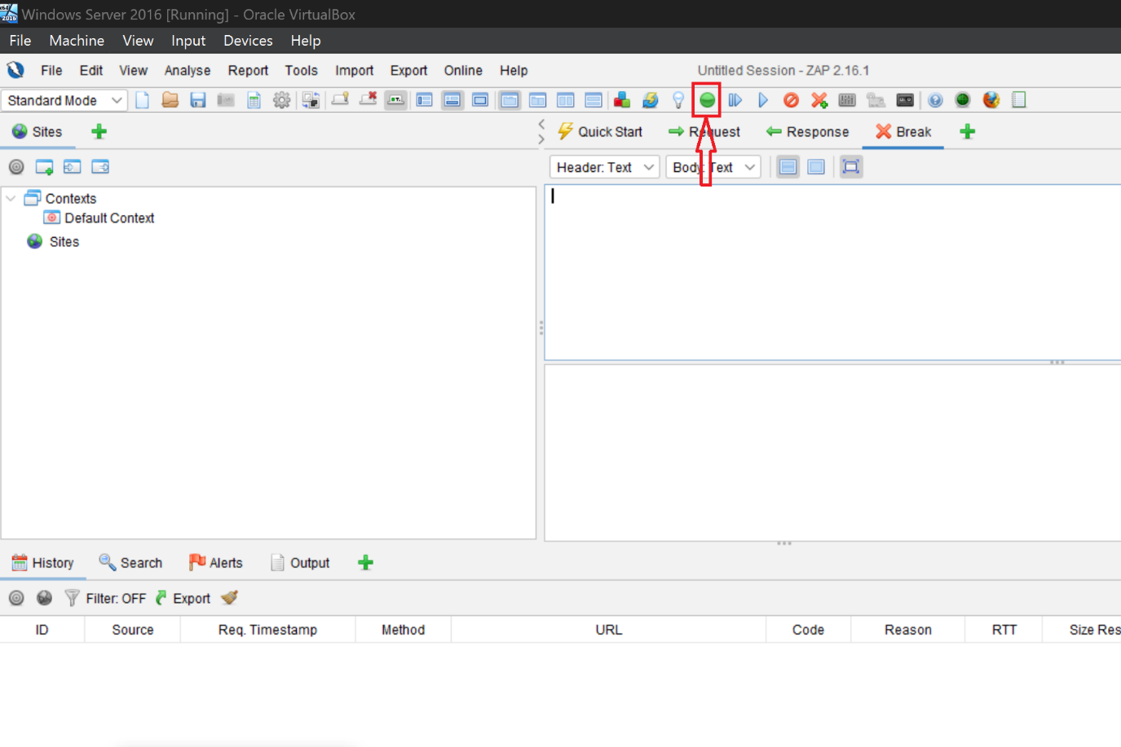

On Windows 10: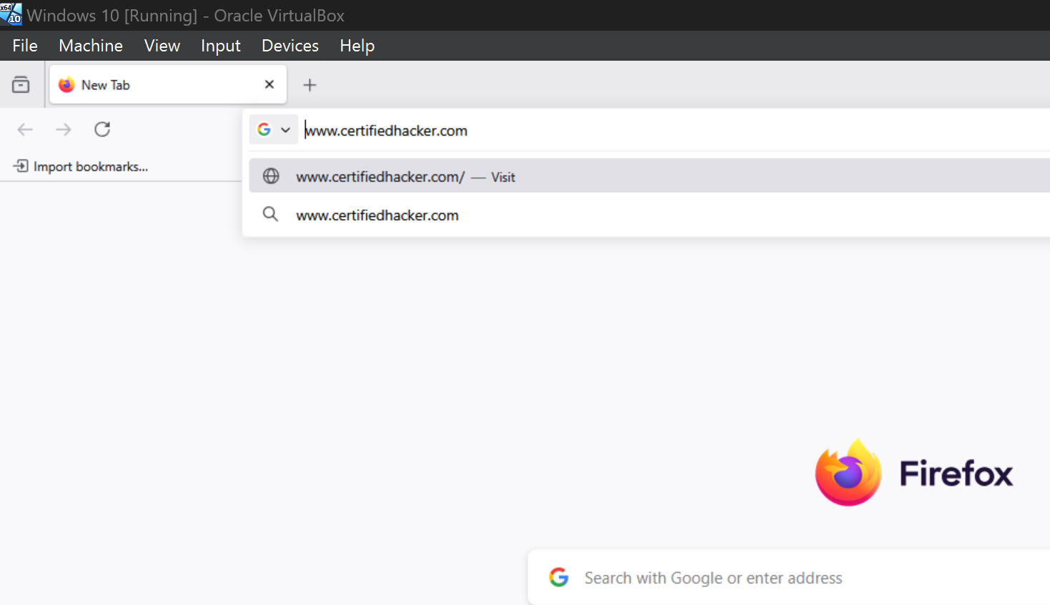

Switching to the attacker machine (Windows Server), ZAP proxy started capturing the requests of the target.
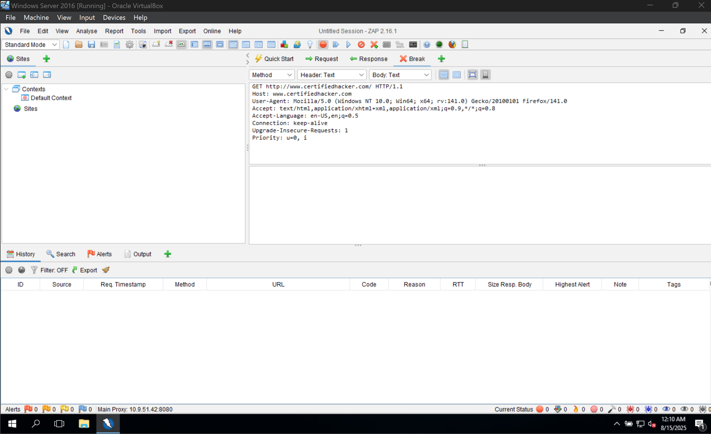

Submitting and stepping to the next request' until GET request of the browsed website is captured. 